INTRODUCTION

API TESTING WITH POSTMAN

The Inventory Management API is a RESTful service designed to efficiently handle product inventory operations such as adding, retrieving, updating, and deleting product information. This project includes a comprehensive Postman collection that not only tests API functionality but also validates performance, structure, and reliability through advanced automated test scripts.
The system interacts with a mock API endpoint to simulate real-world inventory operations. Each API request in the collection is equipped with detailed validations, including status code checks, header verification, response schema validation, and field integrity checks. Additionally, the collection uses Postman Visualizer to provide interactive visual output such as product tables, stock distribution charts, and formatted product detail cards.

API Overview s Architecture
- Introduction to the API
The Inventory Management API is a RESTful service designed to handle basic inventory operations such as product creation, retrieval, updating, and deletion. It enables users to manage product
details efficiently through standardized HTTP methods. The API used in this project is hosted on MockAPI, a platform that simulates real-world API behavior and provides predictable, structured responses ideal for testing.
The API follows REST principles, using resource-based URLs, structured JSON responses, and
stateless communication. This makes it highly scalable, testable, and compatible with various clients including web applications, command-line tools, and automated testing frameworks such as
Postman and Newman.

Base URL
The Inventory Management API is accessible using the following base URL:

https://692abcfc7615a15ff24d874f.mockapi.io/foods

CRUD Operations Overview

GET /foods – Retrieve All Food Items

This endpoint is used to fetch a list of all available food items from the system.

It allows clients to retrieve the entire food menu in a single request.

It helps applications display all available food items to users in real time.

It is commonly used for listing, browsing, and filtering food items in the UI.POST /Products – Add a New Product
- Allows adding a new product to the database.
{
"foodName": "{{food}}",
"foodPrice": "947.09",
"foodMenu": true,
"id": "68"
}

  - POST /food – Add a New Food
  - This endpoint is used to add a new food item to the system.
  - It allows clients to submit food details such as name, price, description, and category.
  - It creates a new food record and saves it to the database.

c. PUT /Products/{ProductID} – Update Product
- Updates a food name, supplier, or stock status.

DELETE /Products/{ProductID} – Delete Product
  - Removes a food from the inventory.
  - Also includes a follow-up request to verify deletion.

API Architecture

RESTful Architecture
The API follows a REST-based architecture, which includes:
    - Client–Server Model:
The client (Postman/Newman) sends requests, and the server (MockAPI) returns JSON responses.
    - Stateless Communication:
Each API request is independent and contains all required information.
    - Uniform Resource Identifiers (URIs):
Resources are accessed using structured endpoints such as /Products/{id}.
    - Standard HTTP Methods:
      - GET → Read
      - POST → Create
      - PUT → Update
      - DELETE → Remove

JSON Data Model
Data flows through the API in JSON format, enabling easy validation and parsing. Example response:

{
"foodName": "taste",
"foodPrice": "947.09",
"foodMenu": true,
"id": "70"
}

MockAPI Backend Simulation
MockAPI provides:
    - Auto-generated IDs
    - Cloud-hosted database
    - Realistic request/response patterns
    - Consistent structure for automated testing
This creates an environment closely resembling a real-world API backend.

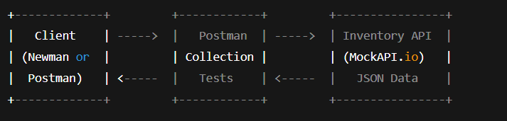
System Diagram

- Newman and HTML Extra Reporter
Newman is the command-line tool for running Postman collections without using the Postman application. It enables automated execution of API tests directly through the terminal, making it ideal for CI/CD pipelines and repeated testing workflows. Developers can run collections, apply environments, and export results with simple commands like:
newman run Inventory_management.postman_collection.json newman run Inventory_management.postman_collection.json -d data.csv
newman run Inventory_management.postman_collection.json -d data.csv -r htmlextra

G.ScreenShots
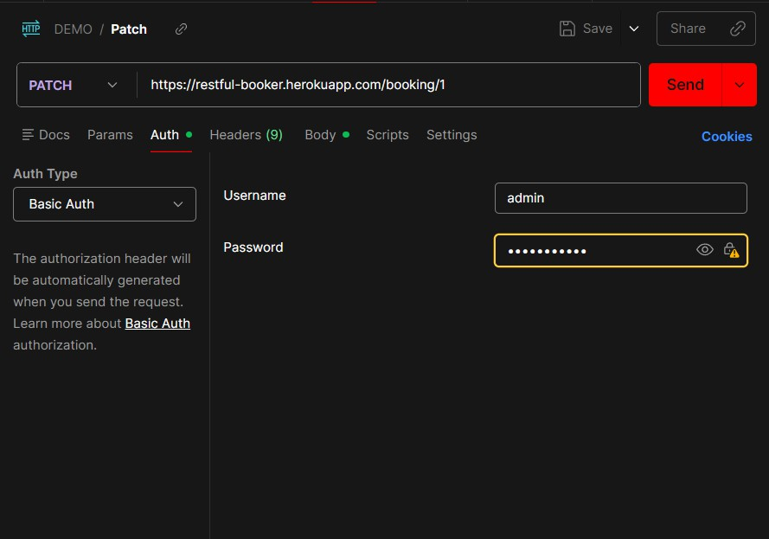

BASIC AUTH
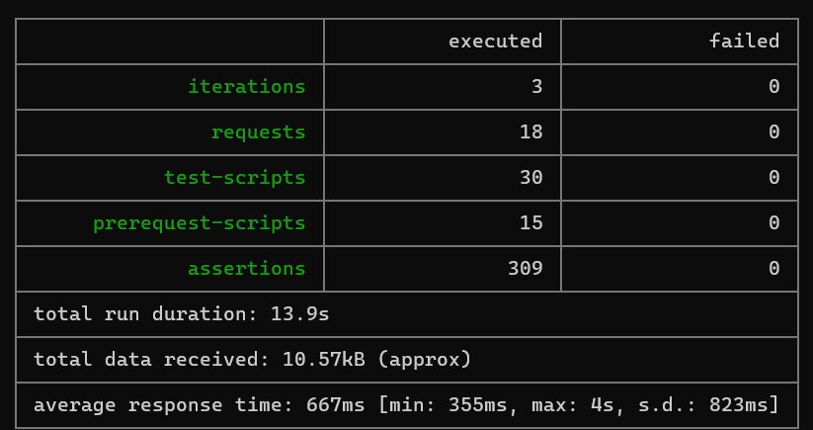

NEWMAN RUN USING CSV
NEWMAN RUN USING JSON

10.CONCLUSION
The Inventory Management API project successfully demonstrates how RESTful services can be tested, validated, and automated using Postman and Newman. Through the use of a structured Postman collection, detailed test scripts, environment variables, and visualizers, the project provides a complete end-to-end approach to API testing. The integration of Newman and the HTML Extra reporter adds automation capabilities and generates professional-quality reports, making the solution suitable for real-world development and CI/CD pipelines. Overall, this project enhances the reliability of API workflows, improves test coverage, and showcases effective tools for modern API testing and documentation.

